# Things to do in WLS console.

For legacy logging using WLS console.

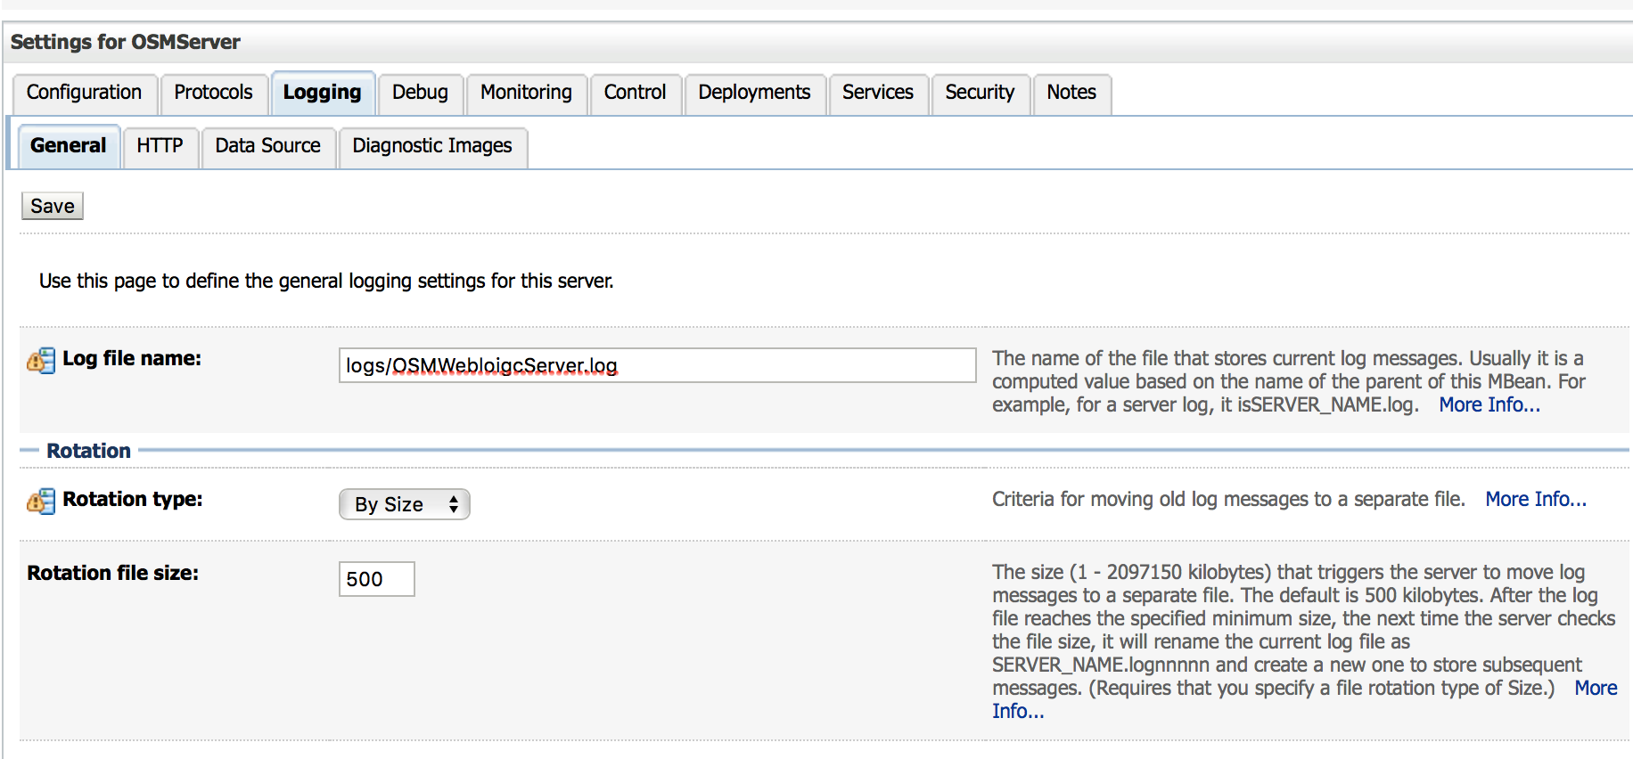

Remove STDOUT and STDERR redirect if enabled .

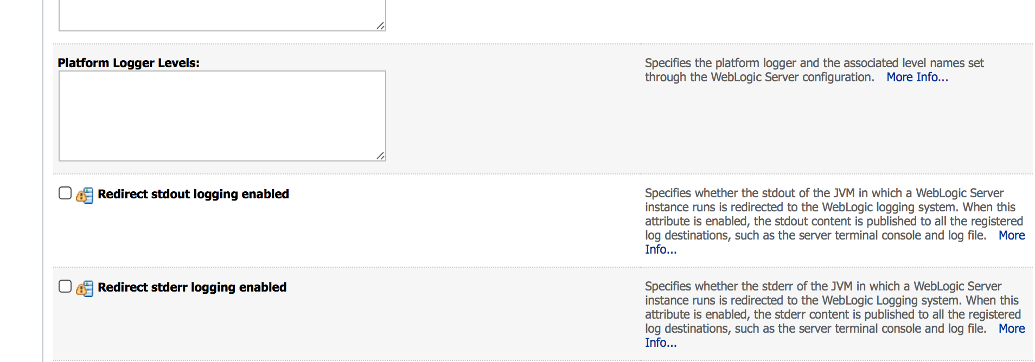

Set SEVERITY LEVEL TO WARNING

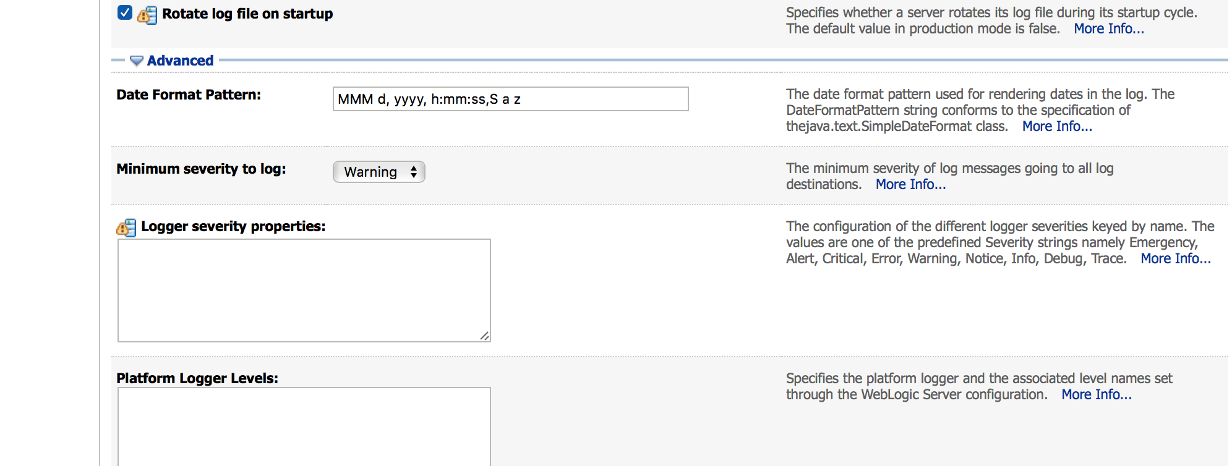

# Things to do in EM console

Go to LOG configuration as shown below

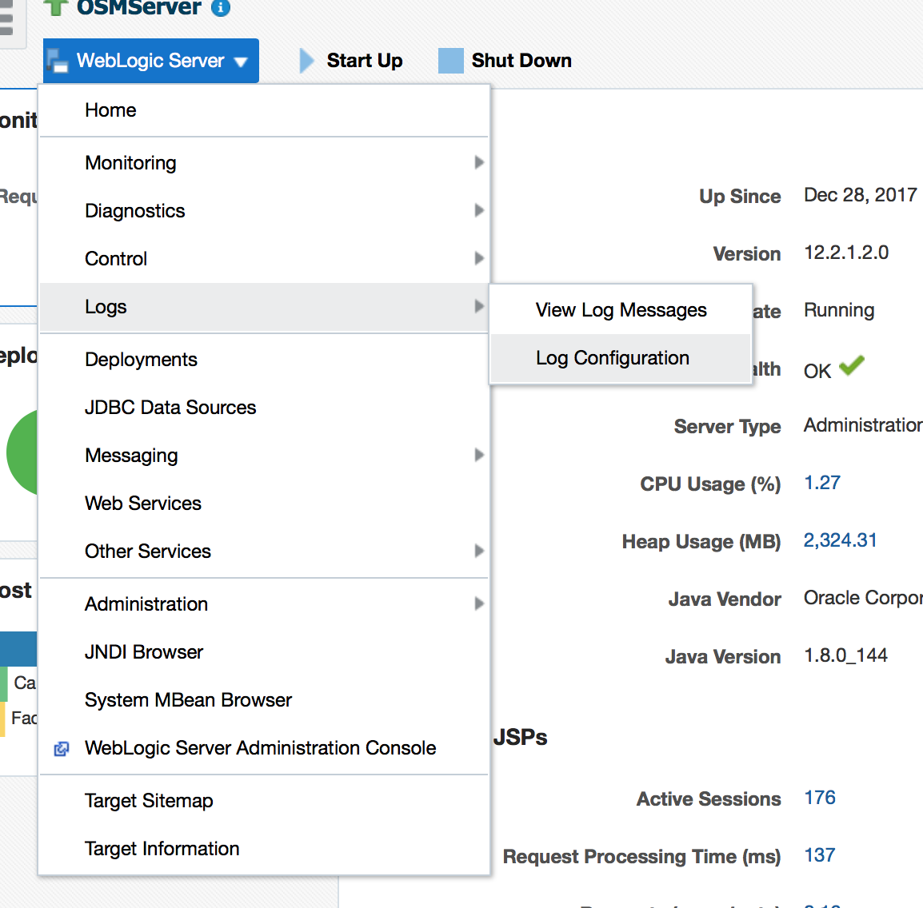

Create two LOG HANDLERS as shown below. One for Automation and one for CORE OSM.

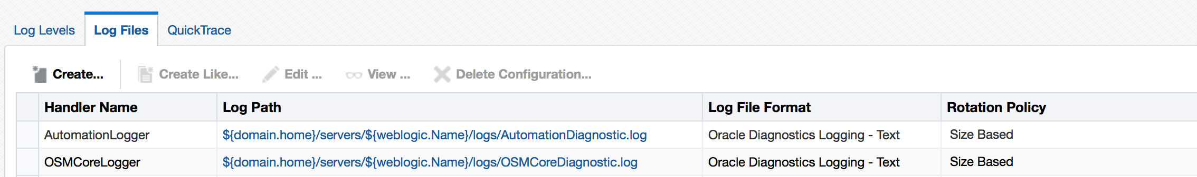

Use the setting as below. HINT : - use buttion CREATE LIKE for copying ROOT handler set up.

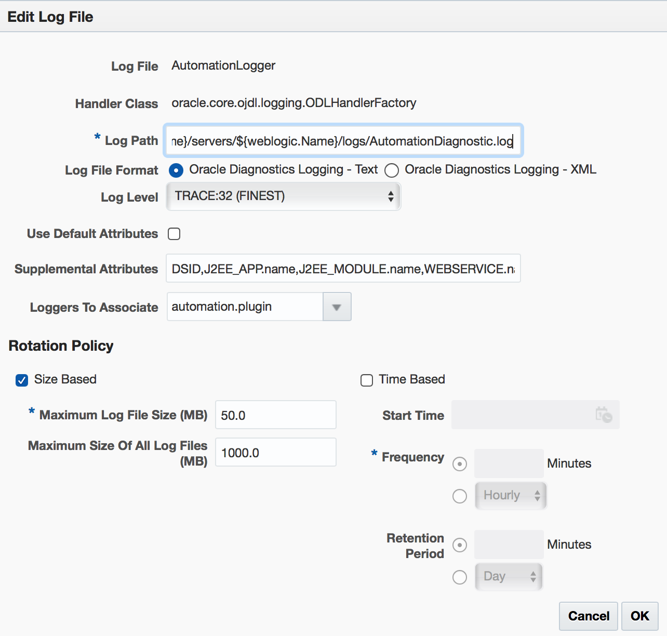

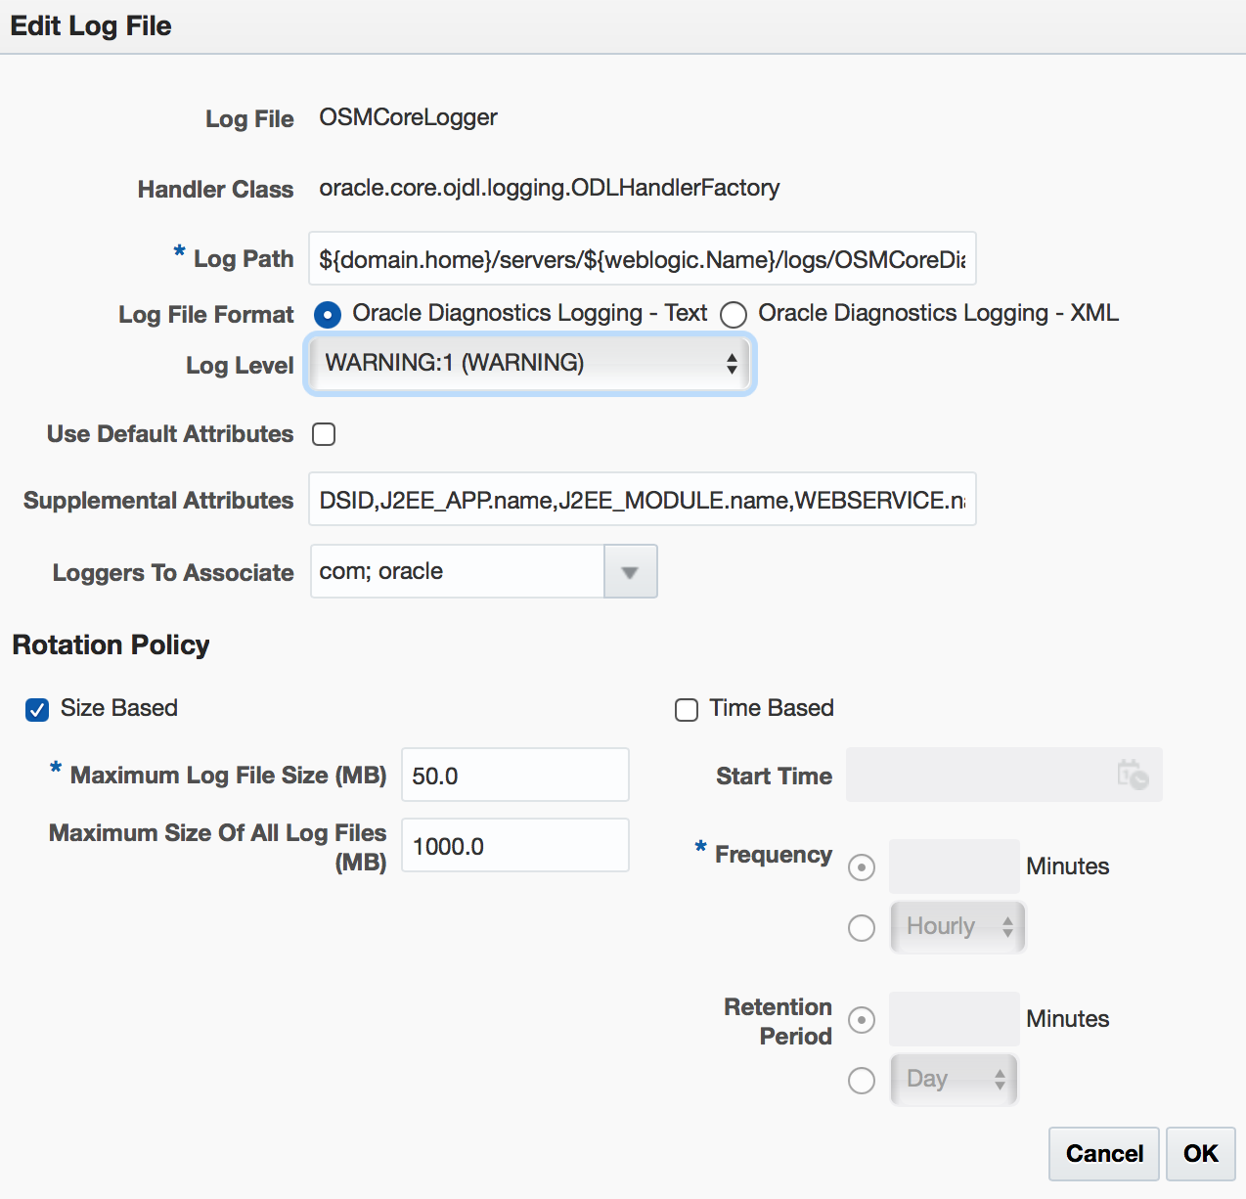

NOW – assign the desired level as required.

VERY IMPORTANT NOTE- DO NOT assign TRACE to CORE handler. This will fill the logs in very

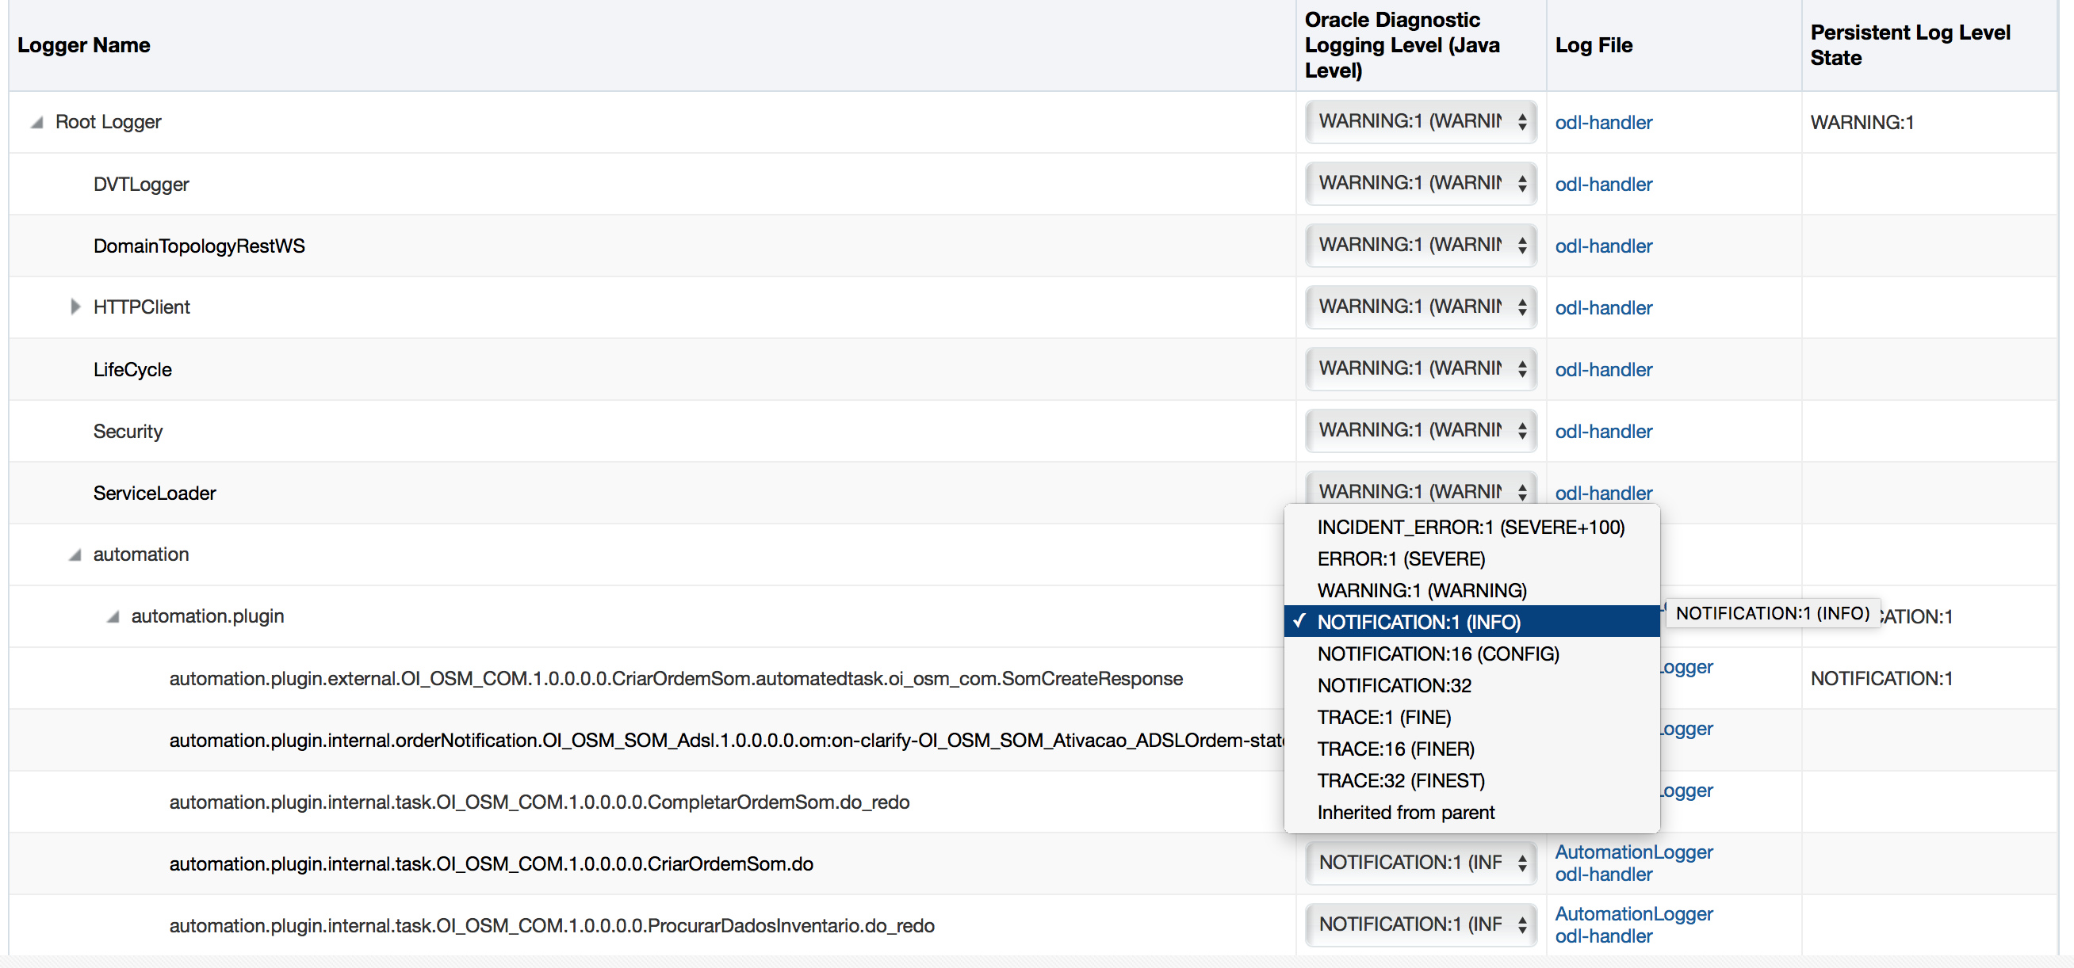

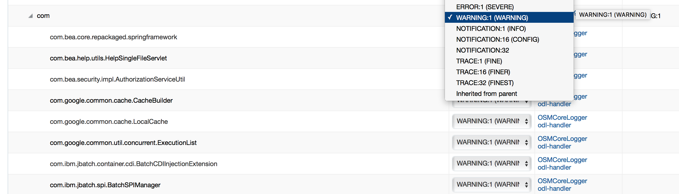

IN code use the level as described below

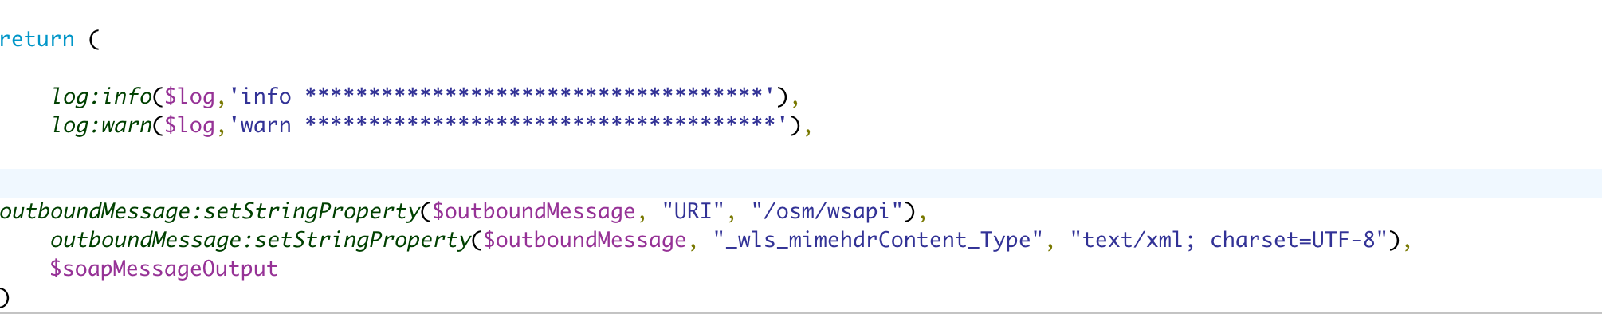

Example-

we can use WARN to print one line (order id, status of order)

we can use INFO to print more information (XML, input and output data)

When we set level in ODL as WARNING we only see the log with the line WARN********* as shown below

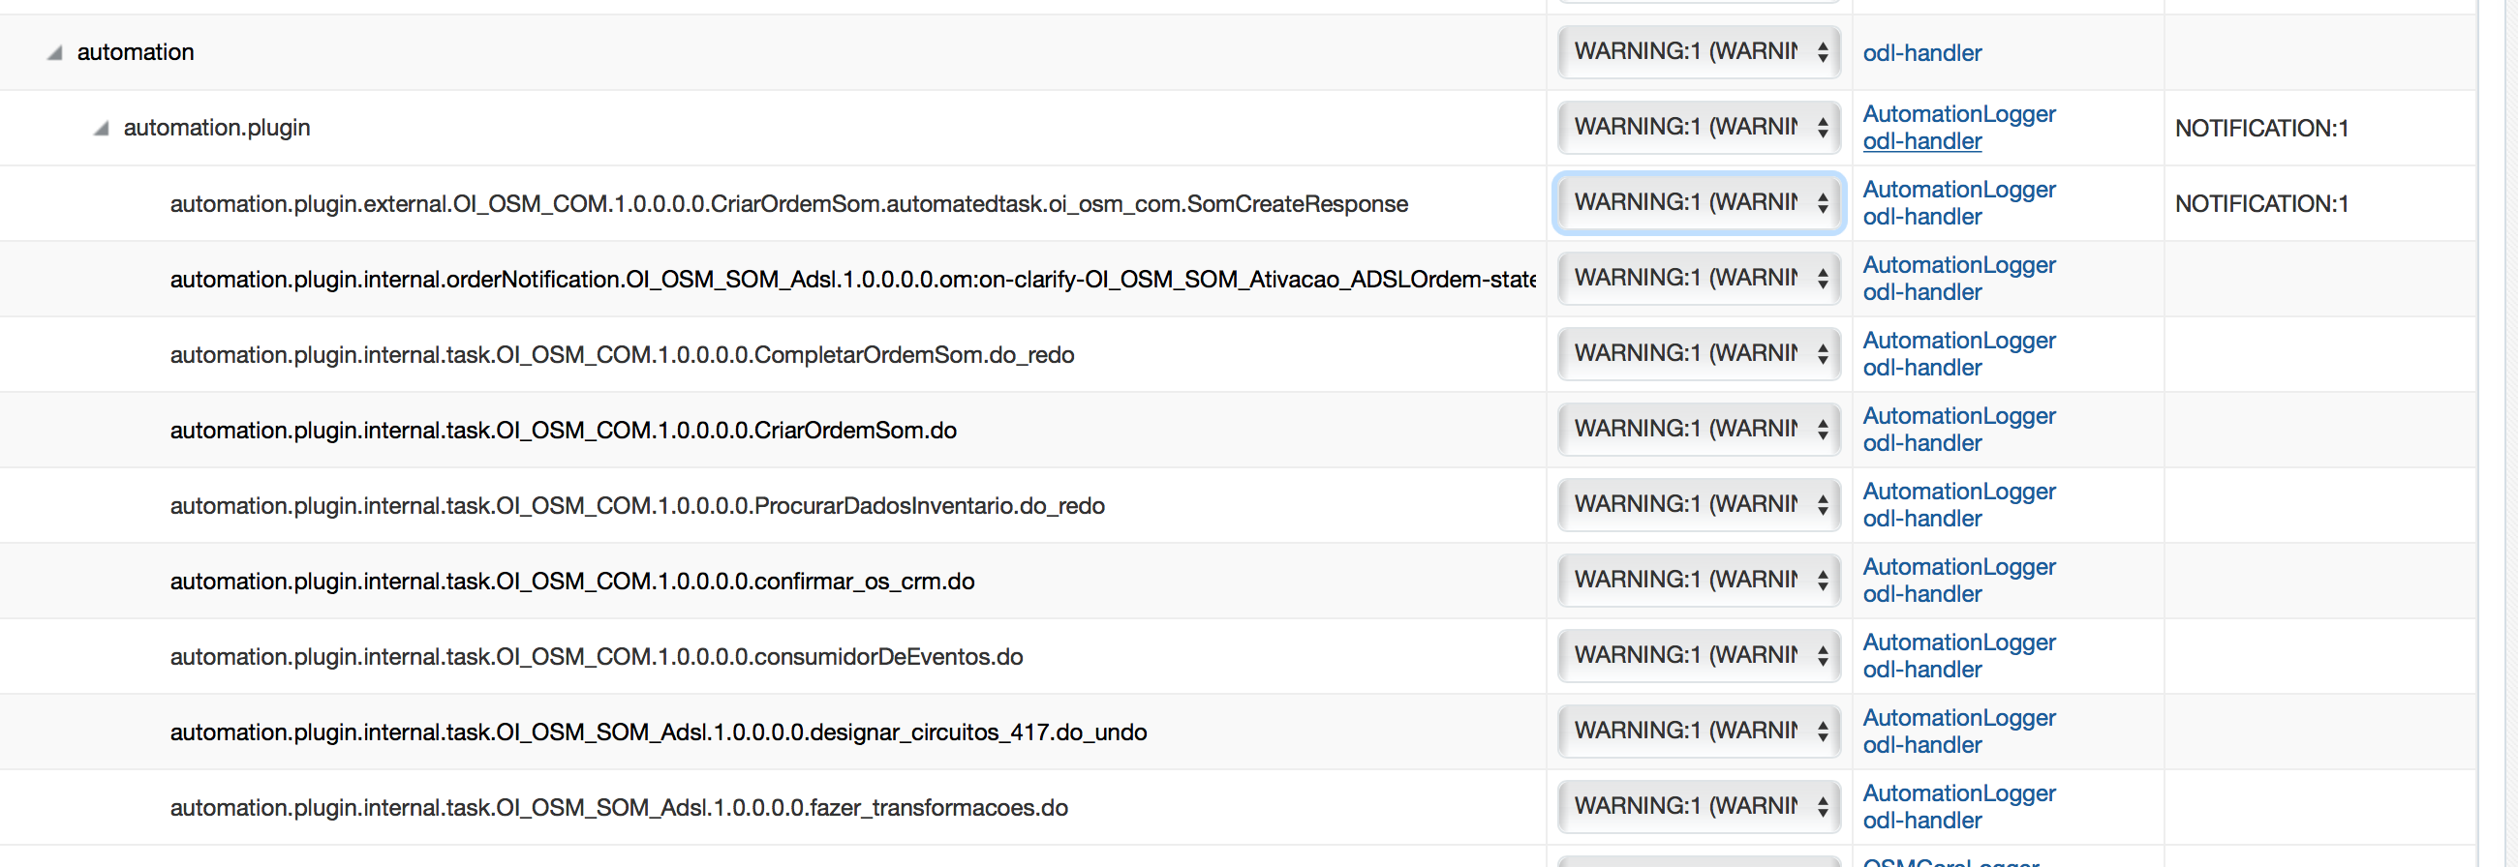

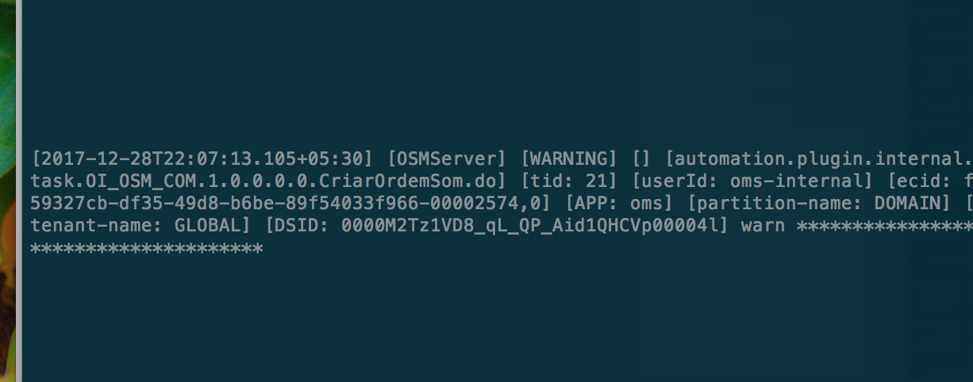

When we set level in ODL as NOTIFICATIO we see BOTH the log with the line INFO********* AND WARN *********as shown below

